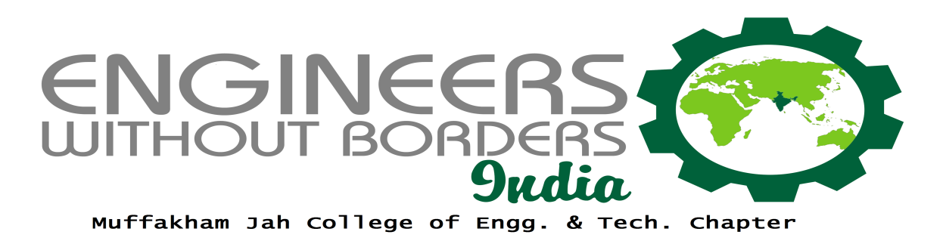

EWB-MJCET a constituent chapter of EWB-INDIA, EWB-INTERNATIONAL delivers holistic solutions for the betterment of the society.

EWB-MJCET utilises the engineering skills to its maximum potential for the development and benefit of the society.
- A constituent student chapter of EWB - India
- Started in the year 2005
- Delivers holistic solutions to rural and urban communities
- Students work with, senior professionals and others NGO’s

Chapter Vision:
- To utilize the engineering skills to its maximum potential for the development and benefit of the society.

Chapter Mission:
- To harness the resources available.
- To develop a database for emerging sustainable and innovative technologies.
- To create awareness among student members to work towards development of the society.

Recruitment Drive:
We firmly believe that everyone has great potential, and when provided with the right opportunity can bring about a tremendous change in themselves and the society.
Every year we conduct a recruitment drive to convince people to work for the betterment of the society
EWB-MJCET proudly conducted a recruitment drive and could get 34 new applications. Our team now consists of 105 members.
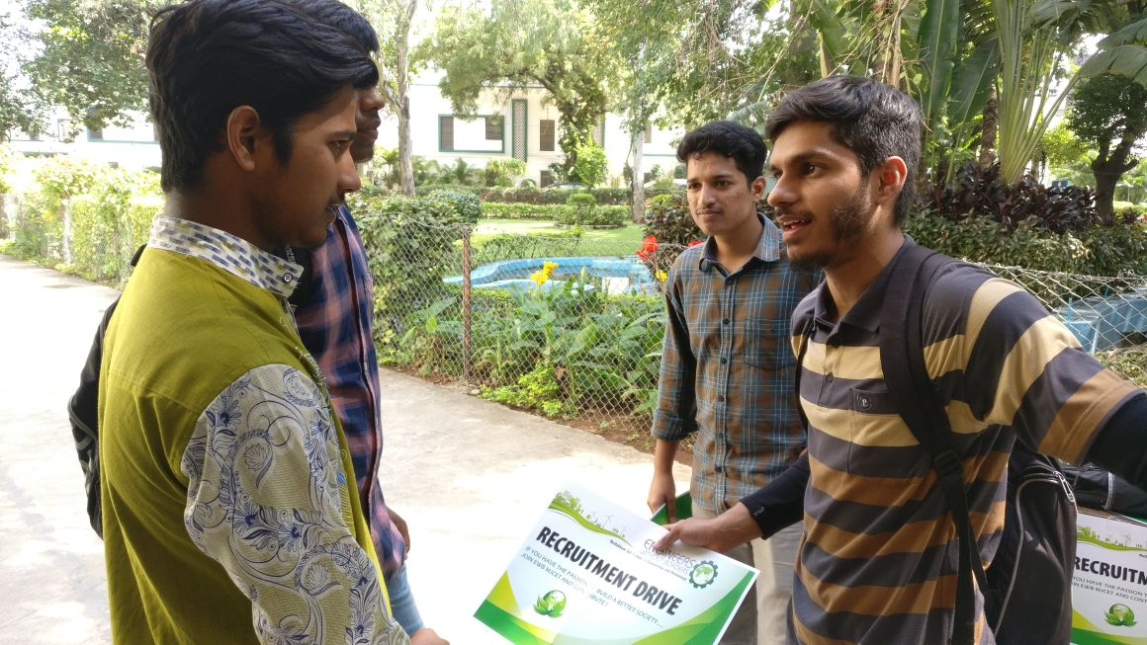:
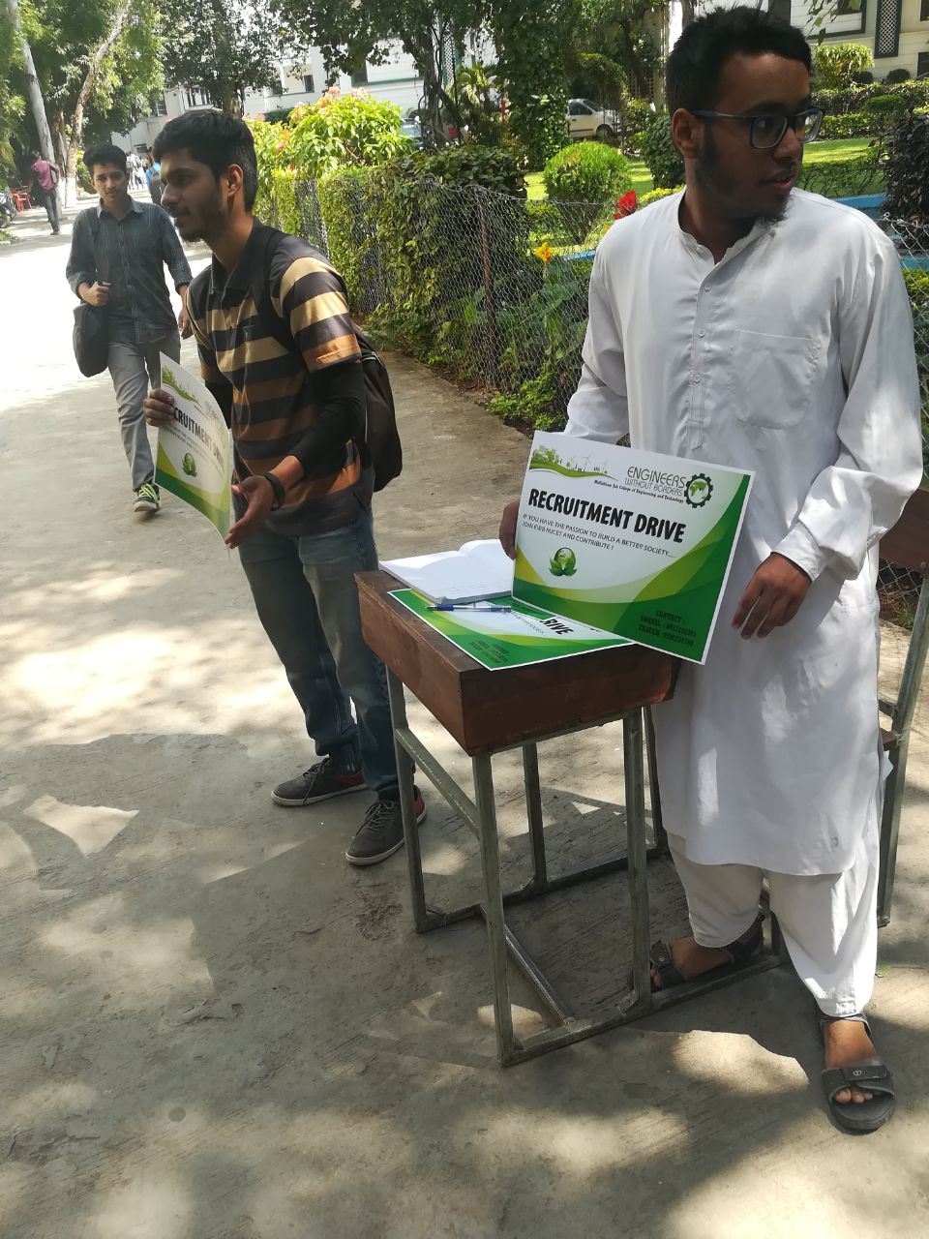

ACTIVITIES UNDERTAKEN IN 2017:
The following activities were taken up and executed by EWB-MJCET in the academic year 2017:
EWB- Green Building:
This project involved the construction of a state-of-the art Green Building designed by Engineers without Borders (EWB) –M.J.C.E.T student chapter. This one-of-its-kind self-sustaining eco-friendly buildingwas constructedwithin the premises of Muffakham Jah College of Engineering and Technology in Banjara Hills, Hyderabad and would serve as EWB-MJCET Student Chapter’s office.

EWB-MJCET Chapter will be the first student chapter in India to implement the construction of Self Sustainable Green Building meeting most of the parameters required for an
International LEED certification.

Green building, which is a hub to "train the trainer " initiative was inaugurated by Honourable Secretary, SUES, Mr Zafar Javeed in the presence of Mr Mahesh Patel (Global engineering Manager ,Pratt & Whitney) and Mr Bharat C Maharaj (Onsite manager, Pratt &Whitney). The project was funded by corporate companies namely Pratt & Whitney, Aerospace & Defence, Cyient Ltd, India and Belcan India Pvt Ltd etc.
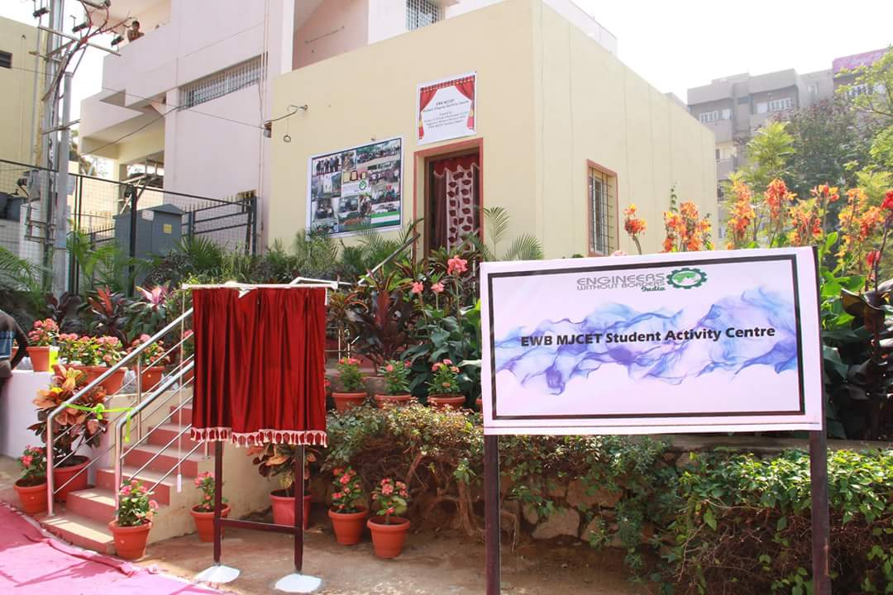
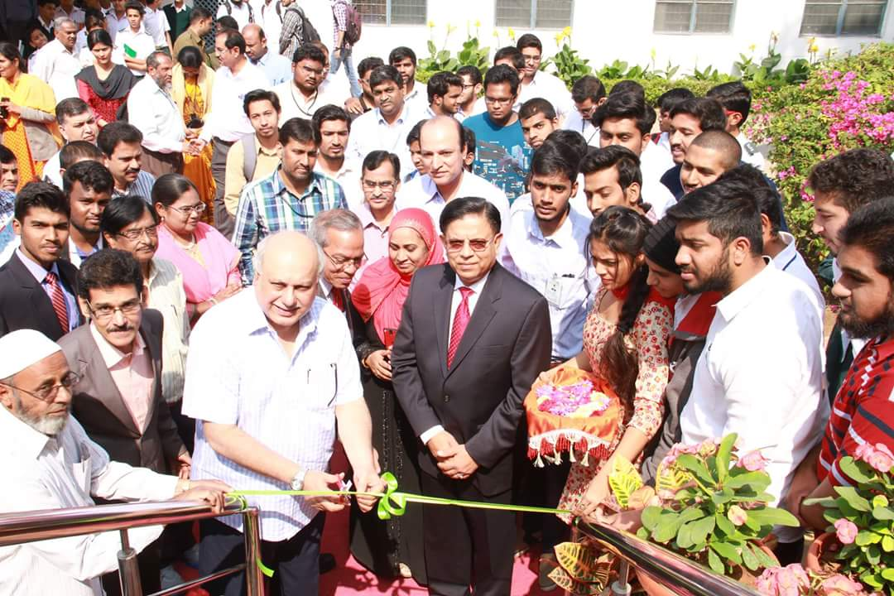
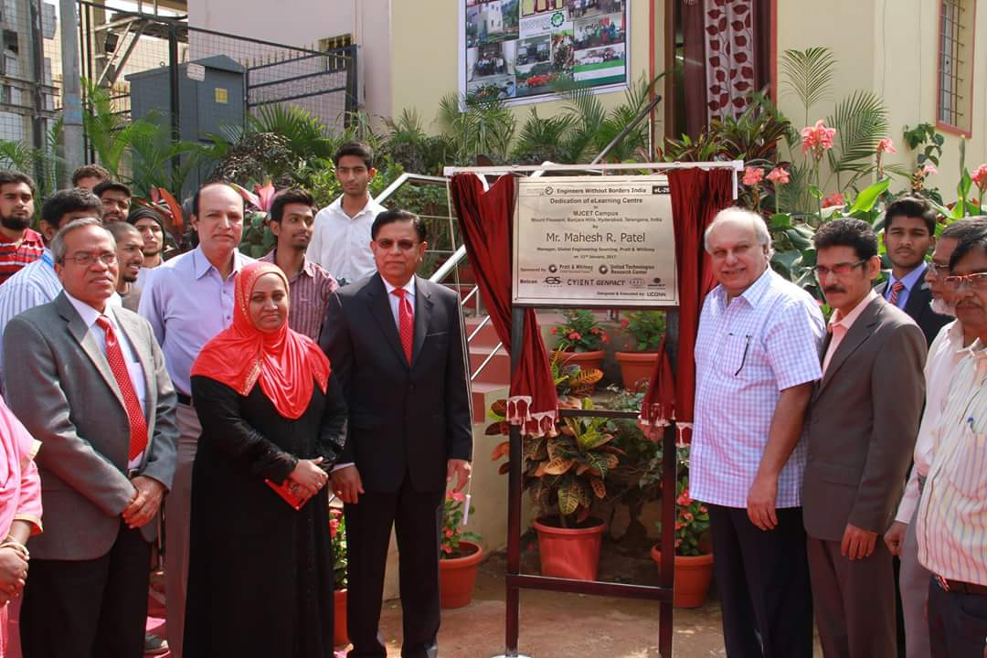

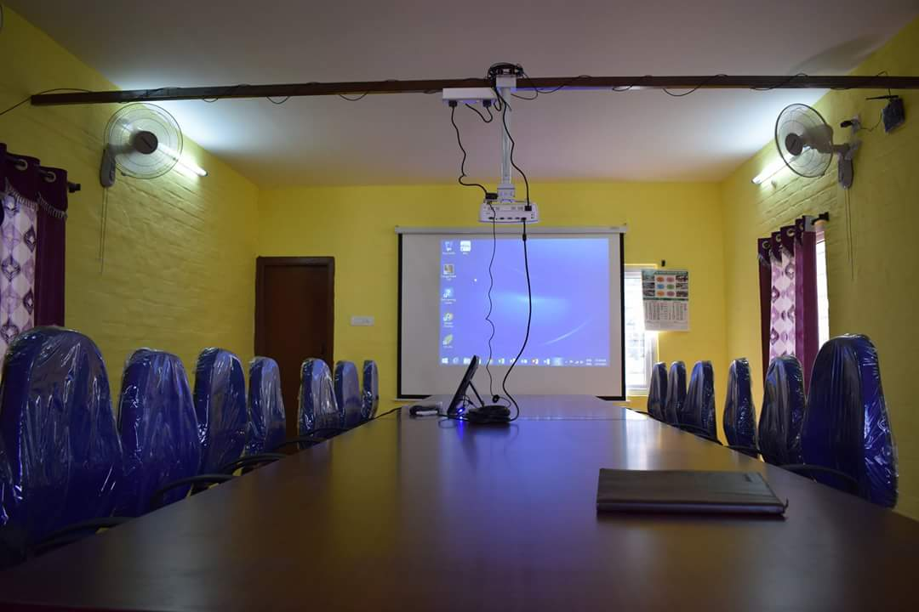
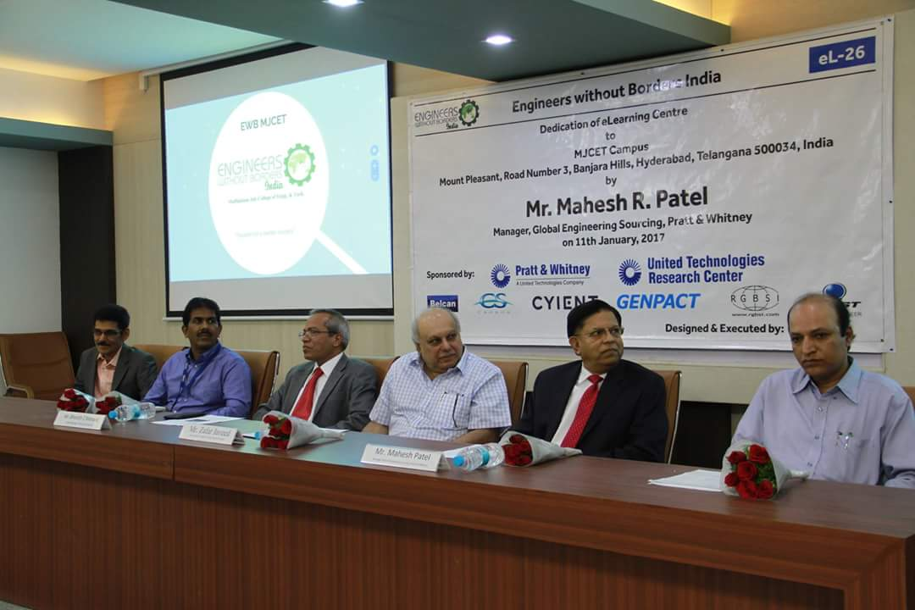

TSE conference 2K17 :

EWB- MJCET student chapter in collaboration with EWB student chapters of the states of Telangana and Andhra Pradesh organised a 2 Day National Conference titled "Technologies for sustainable Ecosystem- TSE 2K17 " on 23rd and 24th March 2017. The venue for the conference was the very own lush green college campus. The objective of the conference was to cater a platform for engineering students to present their work on ecosystem technologies and to provide a platform for possible implementation of the idea for the betterment of the society. Researchers and speakers from various walks of life but dealing with the ecosystem addressed the young engineers of tomorrow during the 2 day conference and the inaugural session had a talk on sustainable technologies and need for maintaining our Ecosystem by Ms Caitlin(a student from University of Connecticut,USA).

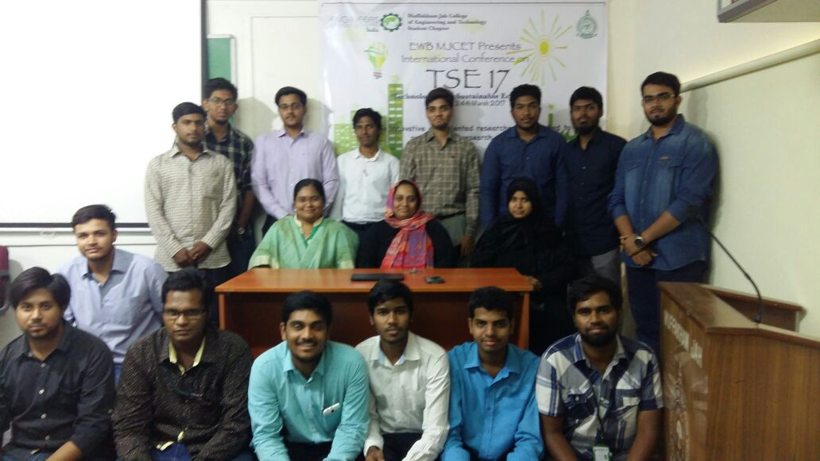

Airtel Hyderabad Marathon 2k17

EWB-MJCET is quite well known name when it comes to volunteering. Our members have been very enthusiastic in all social causes. Airtel has taken a serious account of this and had signed a Memorandum of Understanding (MOU) with EWB-MJCET chapter for a period of 4 yrs. The chapter also holds the title of the best performing volunteering group in Airtel Hyderabad Marathon for 2 years in a row.
EWB-MJCET members volunteered for the Marathon to contribute towards the spirit of running. Around 60 members volunteered for the event and 2 teams of 30 members were allotted on 2 different stations, which were located at Nagarjuna Circle and KBR Park respectively. The volunteers had to report on 4:30AM at the day of the marathon where they were assigned different tasks like cheering the runners, collection of waste, providing the runners with refreshments etc.The marathon was a huge success and received immense media coverage.EWB-MJCET is looking forward to contribute in the organising of the Marathon this year too.
.
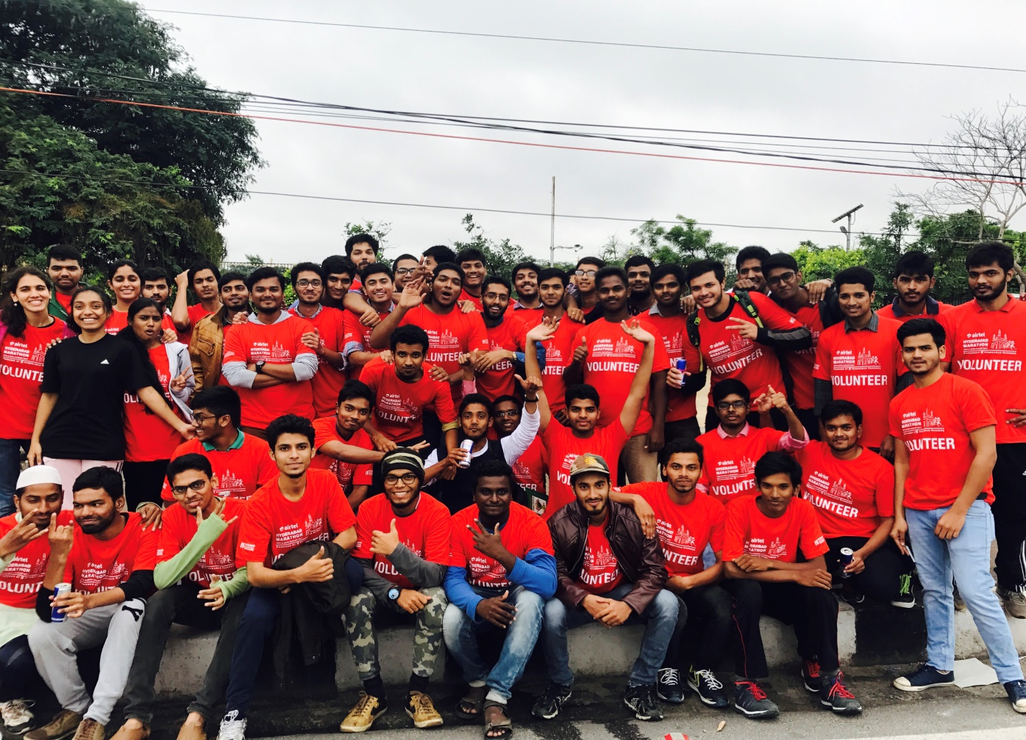

List of the Projects Undertaken:
- ZPHS School Survey -1
- HUL Survey and Satellite Mapping.
- Rasoolpura Sanitation project.
- Fabrication of Foot Operated Tap
- Bio Diesel extraction
- Adoption of School Project
- Solar Fan for Traffic Police booth.
- Paper Collection and Cloth Collection.
- Website Development

ZPHS School Survey:
We surveyed Government Schools for a science fair event where we came across a ZilaParishad High School where the facilities provided to the students was very underwhelming. The school lacked benches and basic amenities such as bathrooms, blackboards etc. We, EWB-MJCET plan to adopt the school for a week in January 2018 and work for providing the school with basic amenities.
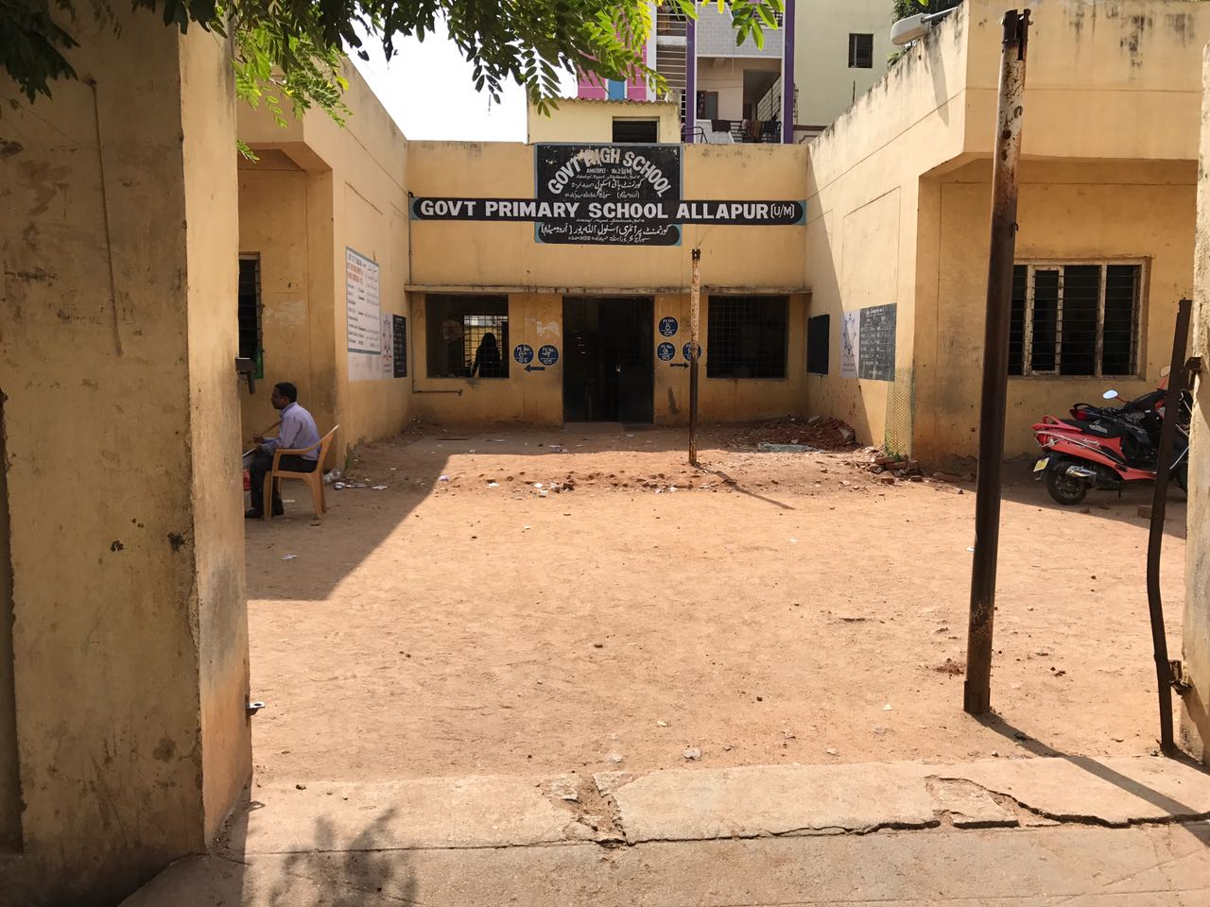
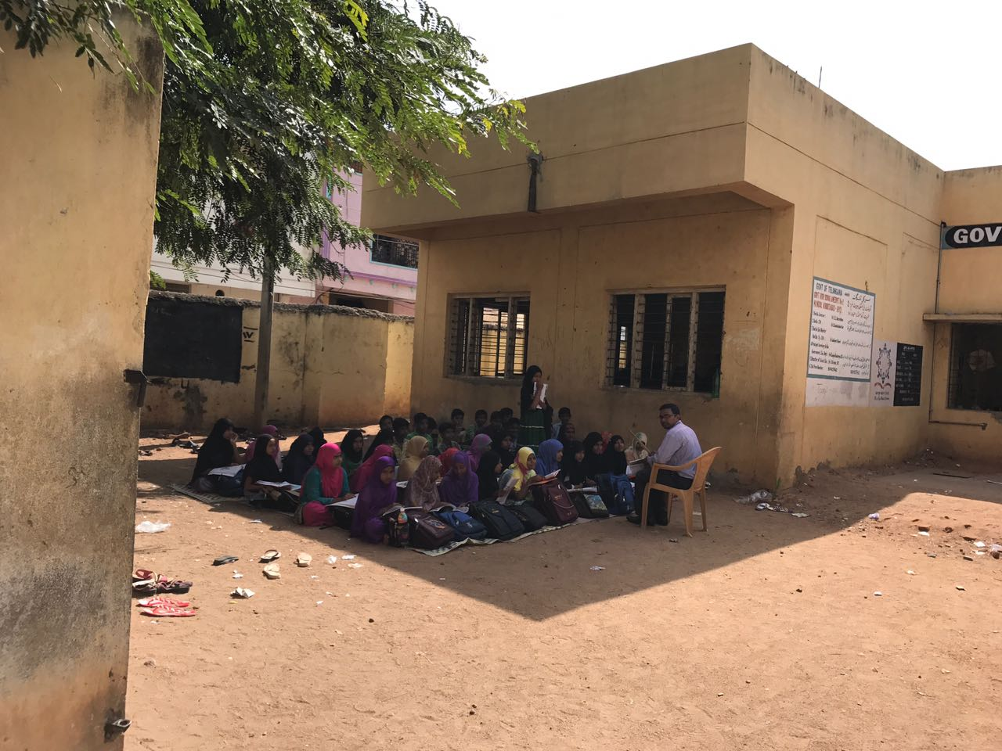

Solar Fan in the Traffic Police Booth:
A Solar Fan with capacitors which can be used in Day and Night Conditions was prepared and fixed on the Traffic Police Booths at the junctions.
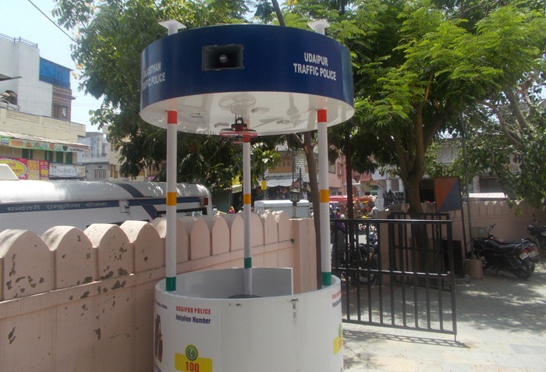
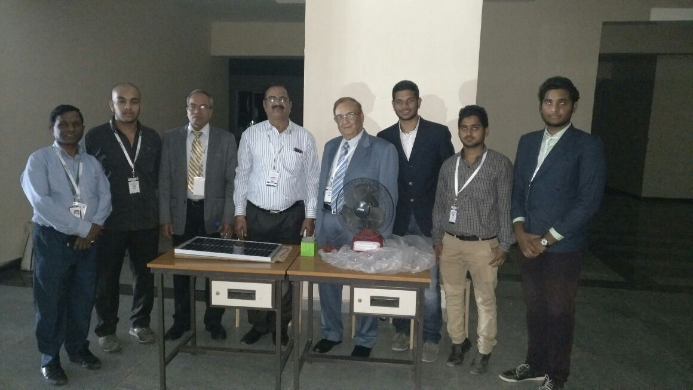
Seminar on Future Projects:

A seminar was conducted on the future projects that will be undertaken by EWB MJCET and the candidates were made aware of the current problems being faced in the society and ideas were circulated on the improvement of the current situation.

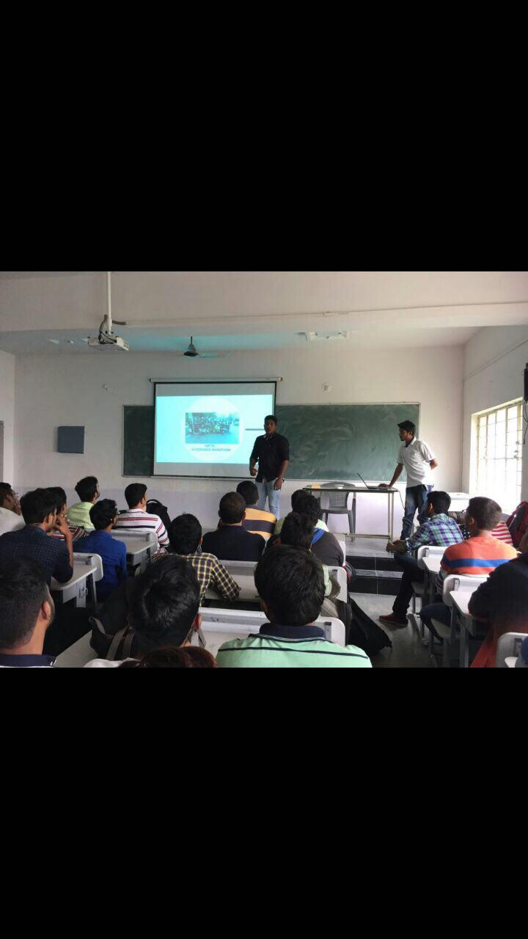

HUL Bus Route Mapping:

Members of our student chapter interned in Hyderabad Urban Lab where the members were asked to ride the city buses and geocode the City bus route locations. This was done to improve the Traffic system by understanding the bus routes in depth and to provide solutions for better traffic management system.
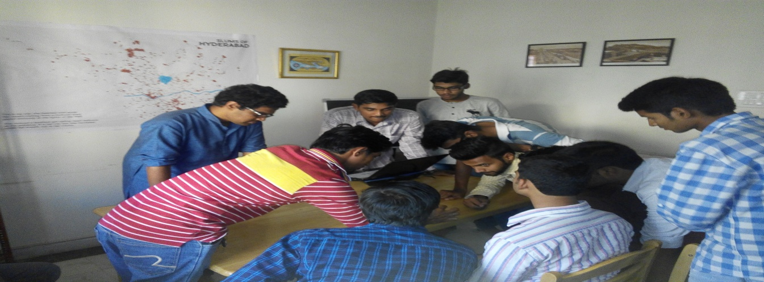

Signing a Memorandum of Understanding with EWB-UCON (University of Connecticut)&Installation of E-learning centres:

Students of EWB-MJCET along with EWB-India and students from University of Connecticut have successfully installed E-learning centers in various schools. Its purpose is to introduce the school children to digital courses in areas of Mathematics and Science. So far 28 E-learning centers have been set up.

Pratt & Whitney and its suppliers contributed more than $93,000 USD(59,40,000 INR) for the set-up of the E-learning centers. In addition to UTC and Pratt & Whitney, United Technologies Research Center, Belcan, Quest global engineering, Cyient, RGBSI , Genpact, CS Canada provided financial support for the project.

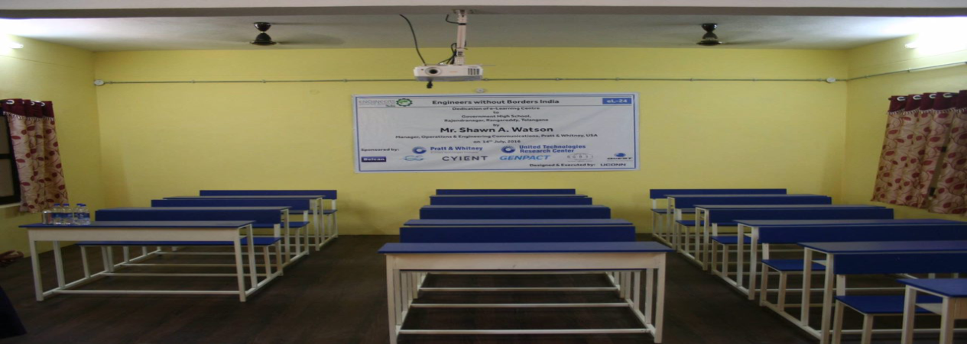
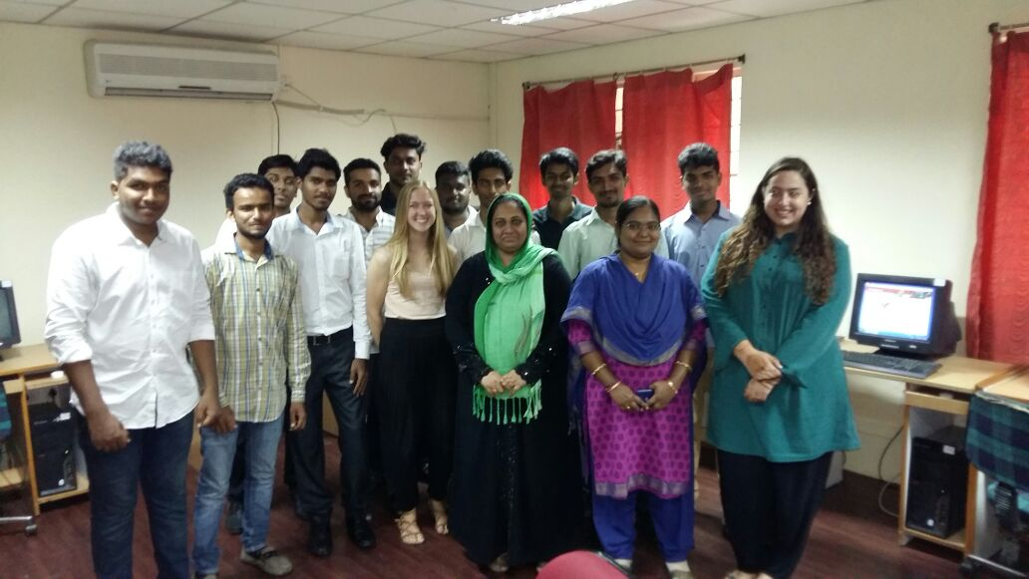

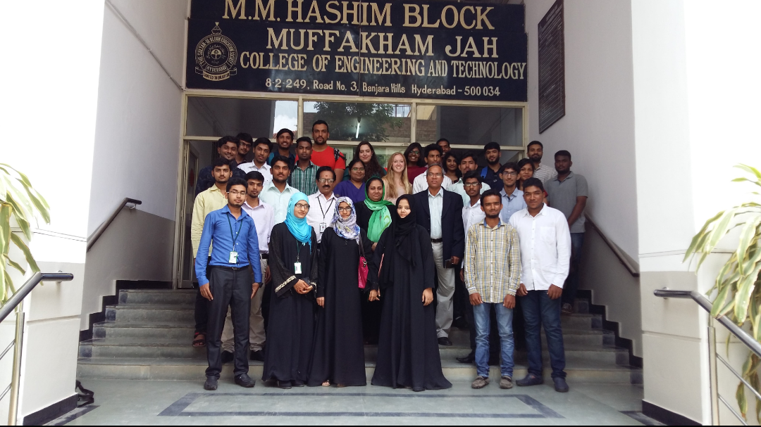

Future Projects
E –Learning Centers
Nalgonda Water Filter
Developing an identified slum
Design of Potential temporary shelter
Solid Waste Management
Solar Pump

